Git Journal

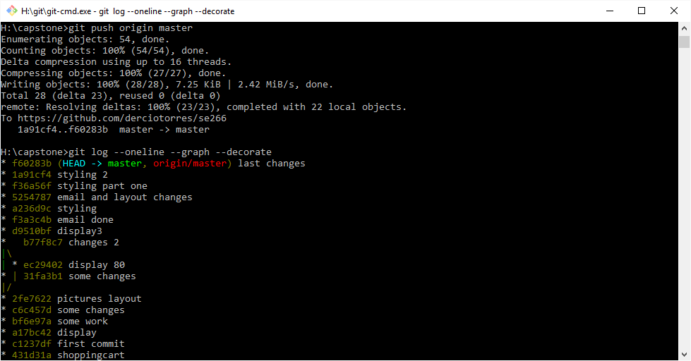

Some the commands I used

git add \*

git commit -m “message"

git status

git push origin master

git checkout <branchname>

git push origin <branchname>

git merge <branchname>

git branch -d <branchname>